Math/Science Lesson Plan for Pets in the Classroom

Class Pet: Bearded Dragon (But this will potentially work for any pet).
Subject(s): Math & Science
Grade: 3-5
Duration: 1 period a month or more often depending on growth rate of pet.
Prior Knowledge/Skills:
- Students should know how to use a measuring tape (we use one for sewing because it is flexible and made of plastic so it won’t hurt our lizard).
- Students should know how to use a double-sided scale.
- Students should know how to be safe around their class pet. This can be more hands-on if the students know how to safely handle/pick up the pet.
Curriculum Connections (for Gr 5, but share similar guidelines with other grades):
Math:
5SP1.2 Formulate a question that can best be answered using first-hand data, and explain why.
5SP2.4 Represent a given set of data by creating a double bar graph, labelling the title and axes, and creating a legend, without the use of technology.
5SP2.5 Solve a given problem by constructing and interpreting a double bar graph.
5SP3.1 Provide examples of events from personal contexts that are impossible, possible or certain.
5SP3.2 Classify the likelihood of a single outcome occurring in a probability experiment as impossible, possible or certain.
5SP3.3 Design and conduct a probability experiment in which the likelihood of a single outcome occurring is impossible, possible or certain.
5SP3.4 Conduct a given probability experiment a number of times, record the outcomes, and explain the results.
5N11.3 Explain why keeping track of place value positions is important when adding and subtracting decimals.
5N11.4 Solve a given problem that involves addition and subtraction of decimals, limited to thousandths.
5N8.1 Express orally and in written form the decimal for a given symbolic, concrete or pictorial representation of a part of a set, part of a region, or part of a unit of measure.
5N2.1 Round decimals to the nearest whole number, nearest tenth or nearest hundredth.
5N1.1 Write a given numeral, using proper spacing without commas.
Science:
1.0 propose a question to investigate and practical problem to solve.
8.0 carry out procedures to explore a given problem and to ensure a fair test, controlling major variables 9.0 select and use tools 14.0 record observations 18.0 compile and display data.
28.0 identify problems as they arise and collaborate with others to find solutions.
GCO 3 (Knowledge): Students will construct knowledge and understandings of concepts in life science, physical science, and Earth and space science, and apply these understandings to interpret, integrate, and extend their knowledge.
Mental Set/Warm Up/Hook:
- Explain that we will be measuring, weighing, adding, and graphing how our pet grows.
- Have the class Pose with the pet and take pictures each time, to serve as a reference and to get the class involved.
- Ahead of time, prepare a “Growth Chart” table to collect the data each time you do a measurement. It should have a column for the date, the weight, and the length of the pet.
- Estimate how long or how heavy the bearded dragon will be each time.
- Class discussion on probability of growth rate and expected results.
Activity:
- Remove the pet from their habitat if it lives in an enclosure.
- To weigh them, we use a two-sided scale, and put our bearded dragon in a plastic container on one side, and add small weights to the platform on the other side until both sides is equal. Then we add up the weights to find the total.
- Remove the bearded dragon to a flat surface like a table. Use the measuring table to measure how long it is from nose to tip of the tail.
- Record the weight and length on the growth chart.
Follow-up/Reinforcement:
- As students get more comfortable with the routine, they can be the ones to handle the beardie and take turns recording their findings on the class chart.
- After recording the growth for the last month of school, use the data on the growth chart to graph the lizard’s results for the year.
- Class discussion about which months the bearded dragon grew more or less, or anything else they notice about the findings.
Differentiated Aspects:
- For more advanced students, you can also do a separate measurement of the empty plastic container used to hold the lizard, and subtract it from the total amount to only get the weight of the lizard and not the lizard + the container.
- For students needing more support, the teacher can do the handling of the lizard or the use of the weights while the class looks on.
- Teachers can use one class growth chart on google docs to access each month and record measurements together as a class on the team board. But each student could also keep track on their own sheet.
Assessment:
- Anecdotal based on experiences weighing and measuring the animal – backed up with photos
- Paper copy of filled in growth chart
- Class discussion
- Final graph of growth for the year
Resources Needed:
- Class pet
- Scale
- container for animal to be weighed in
- measuring tape
- graph paper/growth chart
- pencil
- Possibly teamboard & google docs
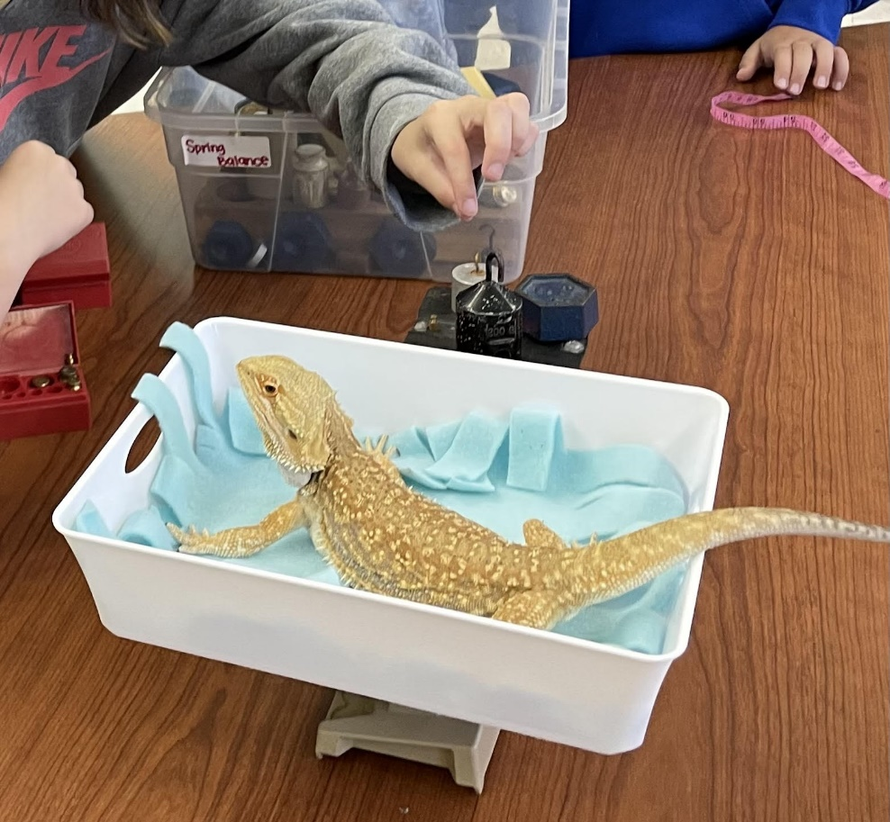
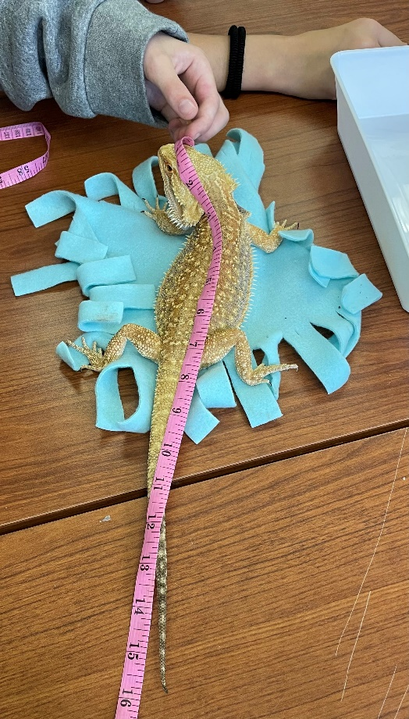

Name: ______________

Growth Chart for _______________
(animal name)

Date | Weight | Length

