Newsletter Sample
Content for Supporters

Newsletter/Blog:

How We Support Kids, Education, and Pets
Did you know that students across the country are benefitting from interacting with pets at school?
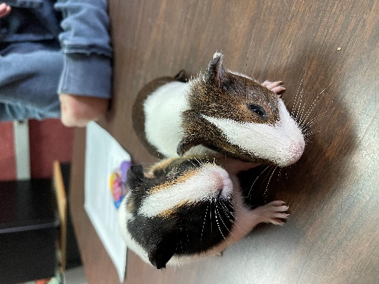
“We’ve only had our Guinea pigs since August but they have made a huge impact on not only the students I work with (I am a Speech and Language Pathologist) but with the whole student body and staff. Two students that I tested this year were eased by holding and petting the Guinea pigs while they completed their evaluation. A group of 5th graders come in before school starts and during some of their recesses to spend time with guinea pigs. This group whether they know it or not are building social skills. One of my students has limited verbal skills, but when he is with Bubbles and Bella the words flow. He has even gone home and told his parents about them (the first time he has made a school to home connection). I cannot say enough about how Pets in the Classroom has impacted our small school.”
~ Yvonne Hayward
Stories like these are one of the reasons we support the Pets in the Classroom grant program.

A Little Bit About Pets in the Classroom:
Pets in the Classroom is an educational grant program that provides financial support to teachers to purchase and maintain small animals in the classroom. The program was established by the Pet Care Trust to provide children with an opportunity to interact with pets—an experience that can help to shape their lives for years to come.
The program, which provides funding for a small animal or pet supplies to pre-kindergarten through 9th grade teachers in both private and public schools, was established by the Pet Care Trust with the knowledge that, while pets are a valuable teaching tool, many teachers have very limited resources for the support of classroom animals. Through the grant program, teachers have can apply for funding to help with the costs of the pet and supplies through a direct, no-hassle application on the Pets in the Classroom website: www.PetsintheClassroom.org.

The Program’s Impact:
Especially in the last few years, teachers have been coping with students experiencing emotional and behavioral problems –anxiety, difficulty focusing, self-control problems, and more. Pets in the Classroom is one of the tools teachers have been able to utilize to give students emotional support during school, whether in-person or through remote learning. The program has provided over 226,000 grants to teachers since its inception, impacting the lives of over 9 million students*.

Learn more about Pets in the Classroom by visiting www.PetsintheClassroom.org.

*Statistics updated 3/2023.

