Teacher Testimonials
Comments shared by Pets in the Classroom Grant Recipients
corresponding images available for download at www.petsintheclassroom.org/sponsor-toolkit

Teacher Testimonials:

- I just wanted to reach out to you all to tell you how THANKFUL we are for this grant in my classroom. We have our pet named Cheerio who is a guinea pig and is the highlight of my students day! My students who have special needs love to help take care of Cheerio and love having Cheerio time once they have completed their work! They have learned independence skills with Cheerio and now understand what it means to take care of him! Cheerio has such an amazing addition to our classroom and we are so thankful for this grant to provide us with funding for Cheerio! Thank you so much from everyone in Mrs. Napper's Class at Forest City Dunbar Elementary School!
~ Abigail Napper, Pets in the Classroom grant recipient

Image: Abigail Napper class pet guinea pig (2)
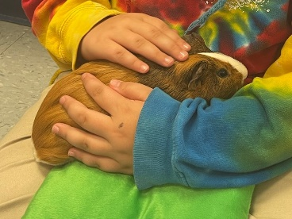

- The pet grant each year gives our classroom students such joy and teaches so much responsibility. The students learn so much about habitats and it has such a calming effect on them in the science center. Thank you so much for this grant.
~ Connie Fox, Pets in the Classroom grant recipient

Image: Connie Fox pets in the classroom
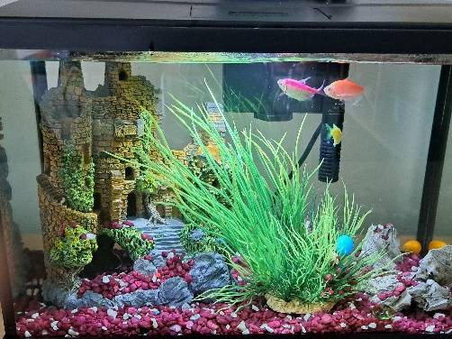

- I don't have any extreme success stories to share about having Rosie our Guinea Pig in class because everyday is extraordinary when she enters the room. Every student (even the most difficult) want to hold her, read to her and take care of her! She increases the enjoyment in my reading class and just the thought of her in class has brought enjoyment and belonging in our classroom.
~ Courtney Waid, Pets in the Classroom grant recipient

Image: Courtney Waid guinea pig (1)
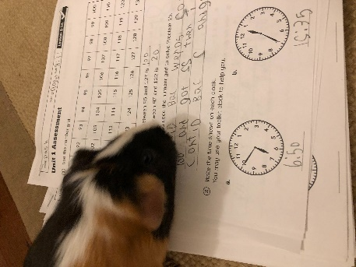

- I was nervous bringing in a bearded dragon to my preschool class after only having a class fish. This has been the best decision not just for myself but for my class as well. We named him Puff the magic dragon (puff for short) and everh day they watch him wander around the room. They hold him. They feel him. It's a great hands on experiment for the kids. I have several that go home and say they want a puff for their birthday! It has truly changed my class for the better!!
~ Haley Duffield, Pets in the Classroom grant recipient

Image: Haley Duffield bearded dragon (2)
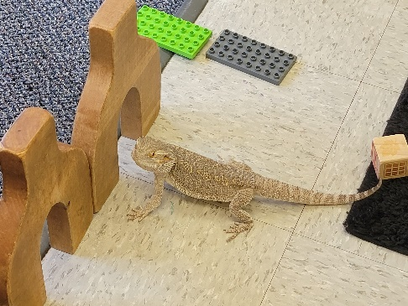

- As a teacher, I’m noticing more and more students with behavioral and social issues. Our guidance counselor has brought down a few students having a rough day to hold the Guinea pigs quietly in the hall and it definitely helped the students decompress and get back to class with no further incidents. I also noticed that when teachers have had a rough day, they’ll come in and just sit in a chair, holding a guinea pig for a while either at the end of the day or during their planning period. The guinea pig will sit in their arms and make their little wheeking sound and it’s hard not to be soothed by their lazy lifestyle. I find myself relaxing just by watching them in their cage. Teachers have suggested that they get their own pictures in our yearbook this year.
~ Jackie Young, Pets in the Classroom grant recipient

Image: Jackie Young guinea pigs (2)
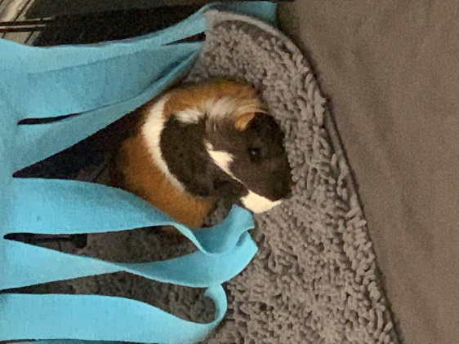

- Although I used Pets in the Classroom to get a bearded dragon for my 4th grade class, she was a wonderful motivator and reward for several students with special needs. When nothing else would calm them down, the mention of visiting Jellybean would immediately turn behaviors around. Students all around the school would get so excited to see and pet her. Students would work hard to get the opportunity to have her on their shoulder as they did their work. Students lined up to give up their recess time to care for her, clean her enclosure, and feed her. I loved this opportunity to share my love of animals with students and provide a rewarding experience for them.
~ Nicole Sisco, Pets in the Classroom grant recipient

Image: Nicole Sisco bearded dragon (3)
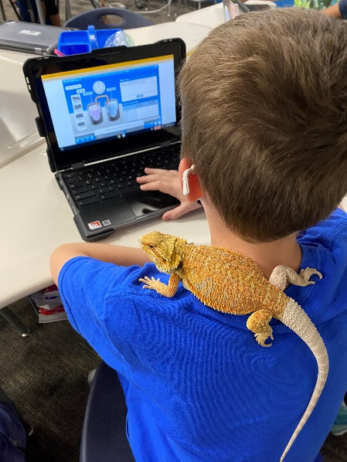

- I love having an aquarium in my room. When students are really upset/depressed, which has happened a lot this year, I sit them in front of the fish. It helps them calm themselves and gives us something to talk about.
~ Robin Konigsberg, Pets in the Classroom grant recipient

Image: Robin Konigsberg class fish aquarium
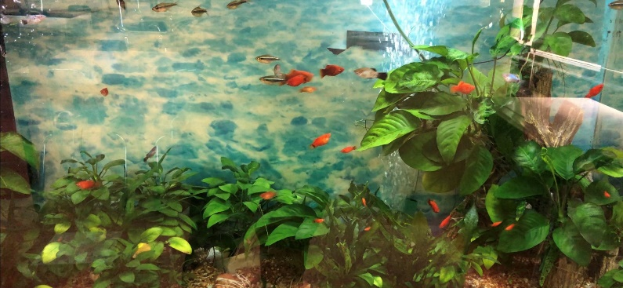

- We received our Pets in the Classroom Grant in October 2021. After two extremely stressful and challenging school years, our Bearded Dragon brought so much joy to our classroom. "Ms. Roz" has provided us with many science lessons, life lessons, and even reading and math opportunities (they LOVE to count how many bugs she can eat)! We are so grateful for Pets in the Classroom for providing us with the resources we needed to give Ms. Roz a home!
~ Ryann Ibanez, Pets in the Classroom grant recipient

Image: Ryann Ibanez pets in the classroom 2
